**CHEESY PASTA BALLS**

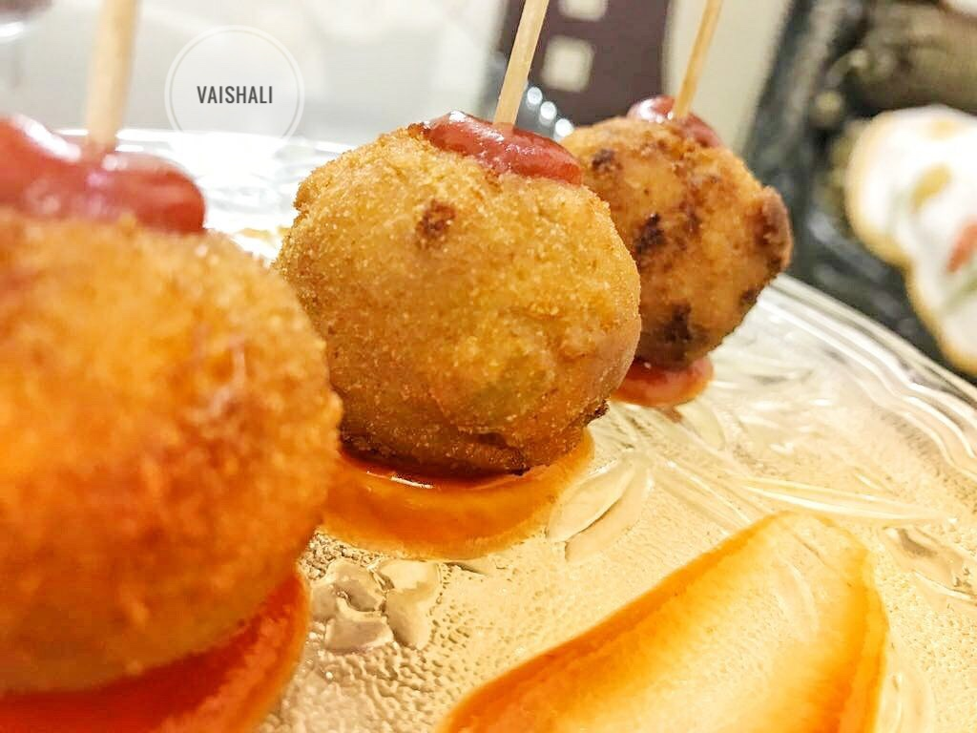

1) Take 1 cup boiled pasta, Add 1 cup Processed cheese, veggies of your choice( cabbage, beans, capsicum, carrot) , 1/2 tsp each oregano and rock salt

2) Mix and mash all these in a bowl

3) Make slurry using 2 tsp each of Cornflour, Maida and water

4) Now make round balls of pasta and put them into freezer for 5 minutes

5) Coat them into slurry and then to breadcrumbs and again put them into freezer for 5 min

6) Now Deep fry them into hot oil and serve it with ketcup 🤗🤗🤗